BUSINESS CASE STUDY

1)Import the dataset and do usual exploratory analysis steps like checking the structure & characteristics of the dataset:
- Data type of all columns in the "customers" table.

SELECT column_name, data_type
FROM `Biz_case.INFORMATION_SCHEMA.COLUMNS`
WHERE table_name = 'customers';

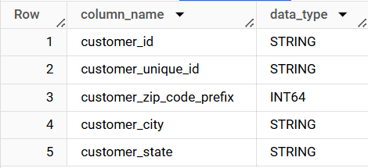

- Get the time range between which the orders were placed.

select min(order_purchase_timestamp) as min_time,
max(order_purchase_timestamp) as max_time
from `Biz_case.orders`;

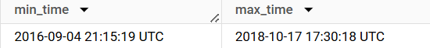

  - Key Insights:
- Orders were placed between the earliest date and the latest date from your data.

  - Recommendations:
- Identify peak order periods within this range to optimize marketing and inventory.
- Focus on the most active periods for promotional activities to maximize sales.

- Count the Cities & States of customers who ordered during the given period.

WITH order_period AS (
SELECT DISTINCT customer_id
FROM `Biz_case.orders`
WHERE order_purchase_timestamp BETWEEN '2016-09-04' AND '2018-10-17'
)
SELECT
COUNT(DISTINCT c.customer_city) AS city_count,
COUNT(DISTINCT c.customer_state) AS state_count
FROM
`Biz_case.customers` c
INNER JOIN
order_period op ON c.customer_id = op.customer_id;

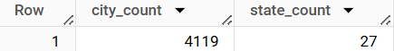

  - Key Insights:
  - There are 4119 cities where customers placed orders, showing wide geographical diversity.
  - Orders came from 27 different states, indicating broad coverage across the country.

  - Recommendations:
    - Focus marketing efforts on major cities within these states to maximize reach.
    - Identify and target states not currently represented to further expand market presence.
    - Create localized marketing campaigns for states with fewer cities to boost orders from those areas.
2) In-depth Exploration:
1) Is there a growing trend in the no. of orders placed over the past years?
select extract(year from order_purchase_timestamp)as year,
count(*) as order_count
from `Biz_case.orders`
group by year
order by year
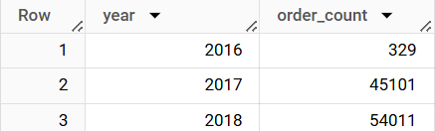

  - Key Insights:
- Orders increased drastically from 329 in 2016 to 54,011 in 2018.

  - Recommendation:
- Ensure the business can handle growing order volumes by scaling operations.
- Invest in customer service to handle the increased demand and maintain satisfaction.
- Allocate resources to areas with the most growth and optimize operations.

2) Can we see some kind of monthly seasonality in terms of the no. of orders being placed?

Select extract(year from order_purchase_timestamp) as year,
extract(month from order_purchase_timestamp) as month,
count(*) as orders_count
from `Biz_case.orders`
group by extract(year from order_purchase_timestamp), extract(month from order_purchase_timestamp)
order by year, month;
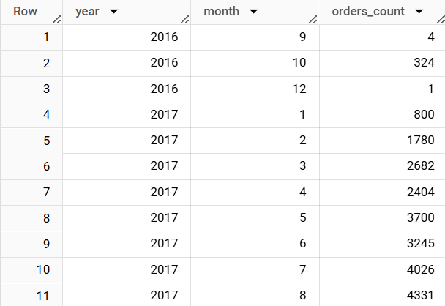
  - Key Insights:
- Max order placed in the month of Nov’2017 which is 7544 and then in Jan’2018 which is 7269.
- Consistent high activity in late 2017 and in early 2018.
- Significant count drop in sept 2018 which is 16 and Oct 2018 which is 4, this indicate some issue and might need further investigation.
  - Recommendations:
- Leverage peak months for major sale event and promotions, and plan inventory and staffing for this months to handle efficiently.
- Plan campaign and customer engagement during peak months.
- Plan strategies to boost sale during low sale month through special offer.

- During what time of the day, do the Brazilian customers mostly place their orders? (Dawn, Morning, Afternoon or Night)
  - 0-6 hrs : Dawn
  - 7-12 hrs : Mornings
  - 13-18 hrs : Afternoon
  - 19-23 hrs : Night

select
case
when extract(Hour from order_purchase_timestamp) between 0 and 6 then “Dawn”
when extract(Hour from order_purchase_timestamp) between 7 and 12 then “Mornings”
when extract(Hour from order_purchase_timestamp) between 13 and 18 then “Afternoon”
when extract(Hour from order_purchase_timestamp) between 19 and 23 then “Night”
End as TimeOfDay,
count(*) as orders_count
from `Biz_case.orders`
group by
case
when extract(Hour from order_purchase_timestamp) between 0 and 6 then “Dawn”
when extract(Hour from order_purchase_timestamp) between 7 and 12 then “Mornings”
when extract(Hour from order_purchase_timestamp) between 13 and 18 then “Afternoon”
when extract(Hour from order_purchase_timestamp) between 19 and 23 then “Night”
End
order by orders_count;

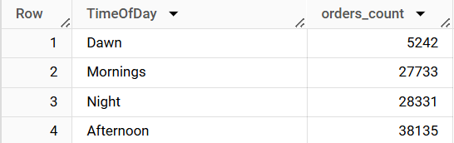
  - Key Insights:
- The peak order time is afternoon i.e between 13-18 which is 38135 orders, customers are most active during afternoon.
- Second highest order count is during Night i.e between 19-23 which is 28331 orders, this is the time likely after they have finished their work or daily activity and are relaxing.
- Third highest order count is during Mornings i.e between 7-12 which is 27733 orders, this indicates customers are engaging in placing order perhaps of their morning routine.
- The least active time is Dawn i.e between 0-6 which is 5242, this time is typically sleeping time which explains lower activity.
  - Recommendations:
- Focus more marketing and promotion on afternoon and night time like special discount/ offers which is time limited.
- In morning hours send promotional notifications , emails and reminder to customers to encourage them to shop in morning.
- Monitor inventory during peak time to ensure popular items well-stocked.
- Enhance user experience by optimizing the website and app performance during peak hours to handle customers.
- Increase customer engagement by giving interactive content on website or app and also feedback gathering from customers.

3)Evolution of E-commerce orders in the Brazil region:
1) Get the month on month no. of orders placed in each state.

select extract(Month from o.order_purchase_timestamp) as Month,
count(*) as order_count, c.customer_state
from `Biz_case.orders` o
inner join `Biz_case.customers` c
on o.customer_id = c.customer_id
group by c.customer_state, extract(Month from o.order_purchase_timestamp)
order by Month, c.customer_state
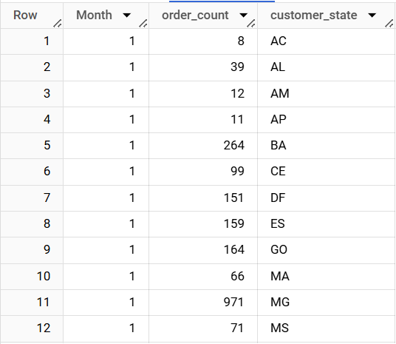
  - Key Insight:
- Highest order placed state is SP in the 1st month i.e Jan with 3351 count , in the 2nd month i.e Feb also SP with 3357 count, in the 3rd month i.e March SP with 4047 count, in April month SP with 3967 , May SP with 4632 count , June SP with 4104 count. In state SP significantly high order place in almost all month which indicates strong customer engagement and robust market in this state.
- Least order place state are RR with 2 order in Jan, AP with 4 order in Feb, AC with 4 orders in March, RR with 4 orders in April, RR with 3 orders in May and so on, so mostly least order placed state is RR we need to understand the reason and according plan more marketing and promotional strategies for this state.
- Moderate states where moderate orders placed represents the potential growth targeted strategies could yield increase sale.
  - Recommendations:
- For least order placed states we need to more focus on marketing and promotional strategies, need to understand reason for low sale by exploring in those states.
- For moderate order placed state need to increase efforts for marketing and promotion.
- Focus on high populated state to increase sale from high , moderate , low sales state .

- How are the customers distributed across all the states?

select customer_state, count(*) as customer_count
from `Biz_case.customers`
group by customer_state
order by customer_count desc
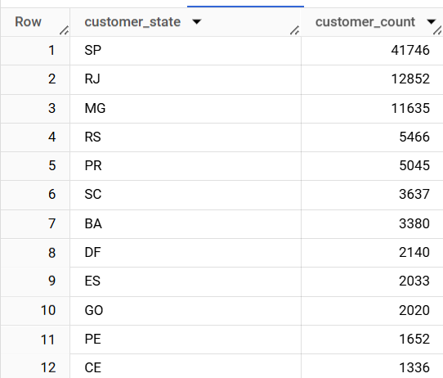

  - Key Insights:
- Highest customer distributes states are SP(41746), RJ(12852), MG(11365), in this state customer engagement is also good as per previous query insights.
- Moderate states are RS, PR, SC, BA, DF ES, GO, PE, CE with range between 5466 – 1336
- Emerging market states are PA,MT,MA, MS, PB, PI, RN, AL, SE, TO, RO having range in between 976 – 253
- Low customer distributed states are AM, AC, AP and RR having range range between 148 – 46.
  - Recommendations:
- Plan more marketing campaigns and digital marketing in states where customer distribution are high.
- Plan special or personalized offers for Moderate customer states which results in more customer engagement.
- Market expansion in emerging market states by understanding customers need, target campaign to increase brand awareness and attract new customers
- Ensure popular product availability by monitoring stock in each state
- Explore low marketing states on ground level to understand the customers need and making them product available from local market by local partnerships.

4)Impact on Economy: Analyze the money movement by e-commerce by looking at order prices, freight and others.
1) Get the % increase in the cost of orders from year 2017 to 2018 (include months between Jan to Aug only).
WITH final AS (
SELECT
EXTRACT(YEAR FROM o.order_purchase_timestamp) AS yr,
SUM(p.payment_value) AS cost
FROM `Biz_case.orders` o
INNER JOIN `Biz_case.payments` p
ON p.order_id = o.order_id
WHERE EXTRACT(MONTH FROM o.order_purchase_timestamp) BETWEEN 1 AND 8
AND EXTRACT(YEAR FROM o.order_purchase_timestamp) BETWEEN 2017 AND 2018
GROUP BY EXTRACT(YEAR FROM o.order_purchase_timestamp)
ORDER BY yr
)
SELECT *,
Round(((LEAD(cost, 1) OVER (ORDER BY yr) - cost) / cost) * 100) AS perc_inc
FROM final;

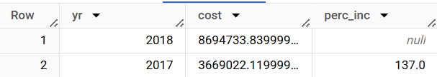

  - Key Insights:
- Significant increase in cost from2017(3669022) to 2018(8694733).
- The percentage increase in cost of orders from 2017-2018 is 137%.
- When we see yearly growth is substantial increase in 2018 this indicates business experience significant growth in orders.
- Financial growth is increased by 137% in costs suggest not only higher orders volume due to increase in customer spending, successful marketing campaigns.
  - Recommendations:
- Replicate continue successful marketing and strategies campaigns from 2017 that lead to 2018’s growth.
- Retain and encourages repeat purchases from your best customers.
- Ensure adequate stock to meet demand for high-growth products and avoid shortages.
- Enhance support services to handle higher order volumes and use feedback to refine products and services
2) Calculate the Total & Average value of order price for each state.

select c.customer_state, round(sum(oi.price),2) as total_price,
round(sum(oi.price)/count(distinct o.order_id),2) as avg_price
from `Biz_case.order_items` oi
inner join `Biz_case.orders` o
on oi.order_id = o.order_id
inner join `Biz_case.customers` c
on c.customer_id = o.customer_id
group by c.customer_state
order by c.customer_state;

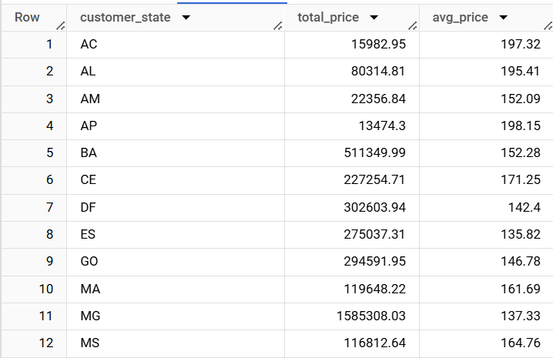

  - Key Insights:
- The highest contributors to total sale states are SP and RJ with 5202955 and 1824092 resp.
- High average spending states are PB , AP with 216 and 198 resp
- Low sales states are AP, RR.
  - Recommendations:
- Invest more in high-sales states (SP, RJ) and high-spending states (PB, AP).
- Target moderate market states with new products and promotions.
- Conduct market research in low sales states to identify and address barriers for sales growth.
- Enhance customer support and gather feedback to improve products and services across all states.

- Calculate the Total & Average value of order freight for each state.

select c.customer_state, round(sum(oi.freight_value),2) as total_freight_value,
round(sum(oi.freight_value)/count(distinct o.order_id),2) as avg_freight_value
from `Biz_case.order_items` oi
inner join `Biz_case.orders` o
on oi.order_id = o.order_id
inner join `Biz_case.customers` c
on c.customer_id = o.customer_id
group by c.customer_state
order by total_freight_value desc

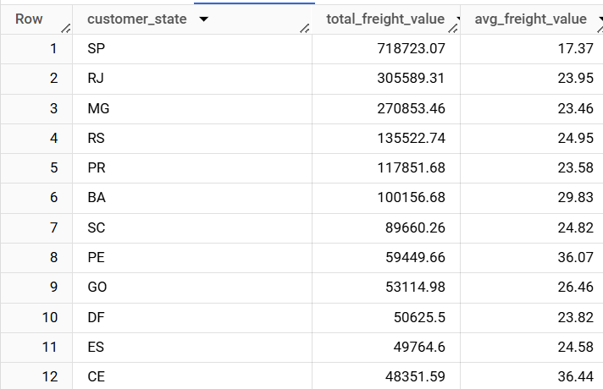

  - Insights:
- High freight cost states are SP and RJ having price 718723 and 305589 resp.
- High average freight states are PB and RR having 48/- freight value.
- Low total freight states are AP and RR with 2788 and 2235 price resp.

  - Recommendations:
- Focus on optimizing logistics and negotiating better shipping rates for high-cost states like SP and RJ.
- Develop strategies to boost market presence in low total freight states such as RR and AP, potentially through local partnerships.
- Conduct a detailed cost analysis to identify factors driving high freight costs in certain states and explore alternative shipping solutions to reduce expenses.

5)Analysis based on sales, freight and delivery time
1) Find the no. of days taken to deliver each order from the order’s purchase date as delivery time. Also, calculate the difference (in days) between the estimated & actual delivery date of an order. Do this in a single query.
select order_id, order_purchase_timestamp, order_delivered_customer_date,
DATE_DIFF(DATE(order_delivered_customer_date), DATE(order_purchase_timestamp), DAY) AS time_to_deliver,
DATE_DIFF(DATE(order_delivered_customer_date), DATE(order_estimated_delivery_date), DAY) As diff_estimated_delivery
from `Biz_case.orders`
order by order_id desc;

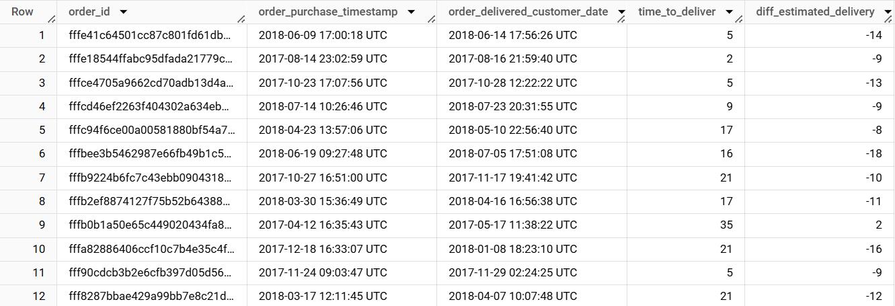

  - Key Insights:
- Orders are delivered within 2 to 38 days, with some taking up to 50 days.
- Many orders arrive earlier than expected.
- A few orders are delivered late.

  - Recommendations:
- Make delivery times more consistent and address any bottlenecks.
- Use early deliveries in marketing to boost customer satisfaction.
- Investigate and fix causes of late deliveries and improve communication with customers.
- Work on better shipping solutions to reduce delivery times and costs.
- Provide real-time tracking and gather feedback to improve service.
2) Find out the top 5 states with the highest & lowest average freight value.

select c.customer_state,
Avg(ot.freight_value) as avg_freight,
dense_rank() over(order by avg(ot.freight_value) desc) as high_rank,
dense_rank() over (order by avg(ot.freight_value)) as low_rank
from `Biz_case.order_items` ot
inner join `Biz_case.orders` o
on ot.order_id = o.order_id
inner join `Biz_case.customers` c
on o.customer_id = c.customer_id
group by c.customer_state
order by avg_freight desc
Limit 5

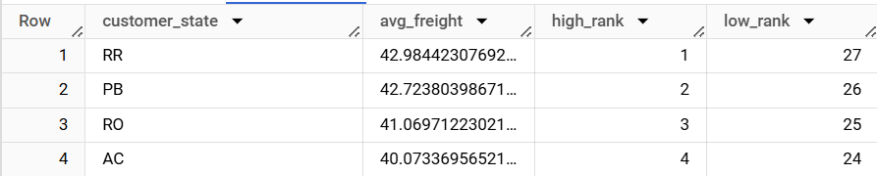
  - Key Insights:
- RR has the highest average freight value at 42.98.
- PB and RO follow closely with average freight values of 42.72 and 41.07 respectively.
- AC has the lowest average freight value among the listed states, at 40.07.

  - Recommendations:
- Review and renegotiate shipping rates or explore more cost-effective logistics solutions in RR, PB, and RO to reduce freight costs.
- Ensure that the efficient logistics solutions used in AC are maintained and possibly implemented in other states to keep freight costs low.

3)Find out the top 5 states with the highest & lowest average delivery time.

With delivery_times as
(select o.order_id, c.customer_state,
DATE_DIFF(DATE(o.order_delivered_customer_date), DATE(o.order_purchase_timestamp), DAY) AS delivery_time
from `Biz_case.orders` o
inner join `Biz_case.customers` c
on o.customer_id = c.customer_id)

select customer_state,
avg(delivery_time) as avg_delivery_time,
dense_rank() over(order by avg(delivery_time) desc) as high_rank,
dense_rank() over(order by avg(delivery_time)) as low_rank
from delivery_times
group by customer_state
order by avg_delivery_time DESC
limit 5

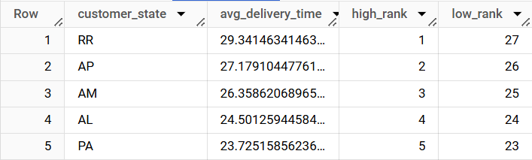

  - Key Insights:
- RR has the longest average delivery time at 29.34 days.
- AP and AM follow with average delivery times of 27.18 and 26.36 days, respectively.
- Al and PA states also show high average delivery times of 24.50 and 23.73 days.

  - Recommendations:
- Focus on improving logistics and transportation routes to reduce delivery times in states with the longest averages (RR, AP, and AM).
- Enhance supply chain efficiency to ensure faster deliveries, particularly in states AL and PA.
- Implement tracking systems to monitor and optimize delivery processes, reducing overall delivery times.

4)Find out the top 5 states where the order delivery is really fast as compared to the estimated date of delivery.
With fastest_delivery as(
select o.order_id, c.customer_state,
DATE_DIFF(DATE(order_delivered_customer_date), DATE(order_estimated_delivery_date), DAY) As diff_estimated_delivery
from `Biz_case.orders` o
inner join `Biz_case.customers` c
on o.customer_id = c.customer_id)
select customer_state,
avg(diff_estimated_delivery) as avg_diff_estimated_delivery,
dense_rank() over(order by avg(diff_estimated_delivery) desc) as high_rank,
dense_rank() over(order by avg(diff_estimated_delivery) ASC) as low_rank
from fastest_delivery
group by customer_state
order by avg_diff_estimated_delivery
limit 5;
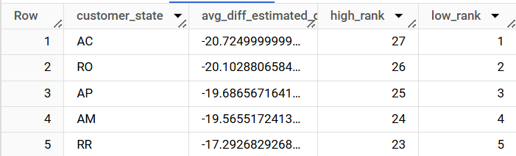
  - Key Insights:
- AC has the fastest average delivery time, with orders arriving about 20.72 days earlier than estimated.
- Other states with quick deliveries include RO, AP, AM , and RR.
- These states consistently deliver earlier than the estimated dates, showing efficient logistics and planning.

  - Recommendations:
- Highlight these early deliveries in marketing campaigns to boost customer satisfaction and trust.
- Use this as a selling point to attract more customers in these states.
- Analyse the logistics and operational strategies in these states to replicate their success in other regions.

6) Analysis based on the payments:
1) Find the month on month no. of orders placed using different payment types.

select count(o.order_id) as order_count, p.payment_type,
extract(month from order_purchase_timestamp) as month
from `Biz_case.payments` p
inner join `Biz_case.orders` o
on p.order_id = o.order_id
group by month, p.payment_type
order by month, p.payment_type;

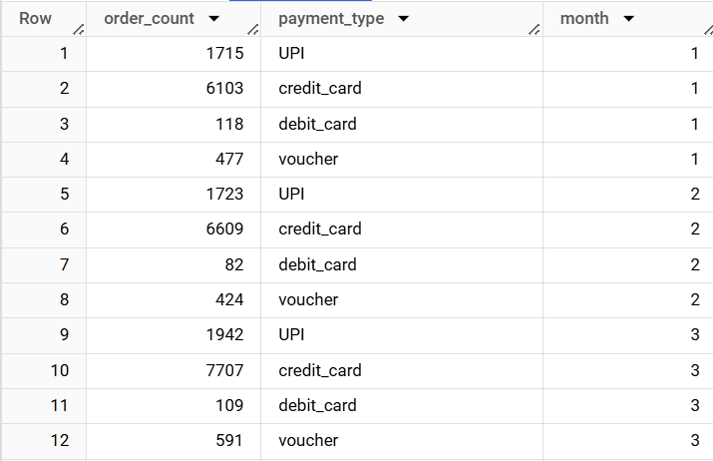

  - Key Insights:
- Credit Card is the most used payment method.
- UPI shows consistent usage with significant order counts.
- Voucher and Debit Card are less frequently used, with lower order counts across the months.

  - Recommendations:
- Capitalize on the popularity of credit cards by offering more promotions and discounts for credit card users.
- Improve and advertise UPI services, given their steady use, to attract more customers.
- Introduce special offers or loyalty rewards for customers using vouchers and debit cards to boost their usage.

2) Find the no. of orders placed on the basis of the payment installments that have been paid.

Select payment_installments, count(order_id) as installment
from `Biz_case.payments`
where payment_installments >=1
group by 1
order by 2 desc

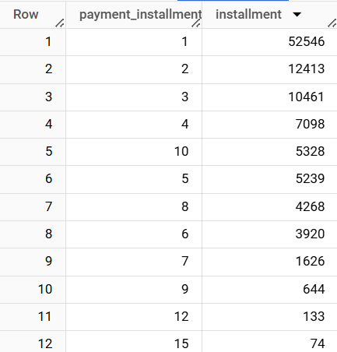

  - Key Insights:
  - The most common instalment plan is for 7 months, with a total of 1,626 transactions.
  - instalment of 9 months and 12 months are also relatively popular, with 644 and 133 transactions, respectively.
  - Longer instalment plans, such as 24 months, 20 months, and 18 months, have fewer transactions, indicating less popularity.
  - instalment plans longer than 21 months are rarely used, with transactions as low as 1 to 3.

  - Recommendations:
- Promote and provide more incentives for the 7, 9, and 12-month instalment plans since they are the most popular among customers.
- Consider simplifying or reducing instalment plans longer than 15 months.
- Provide more flexible options around the popular 7, 9, and 12-month durations.
- Collect customer feedback on instalment preferences to improve offerings.

